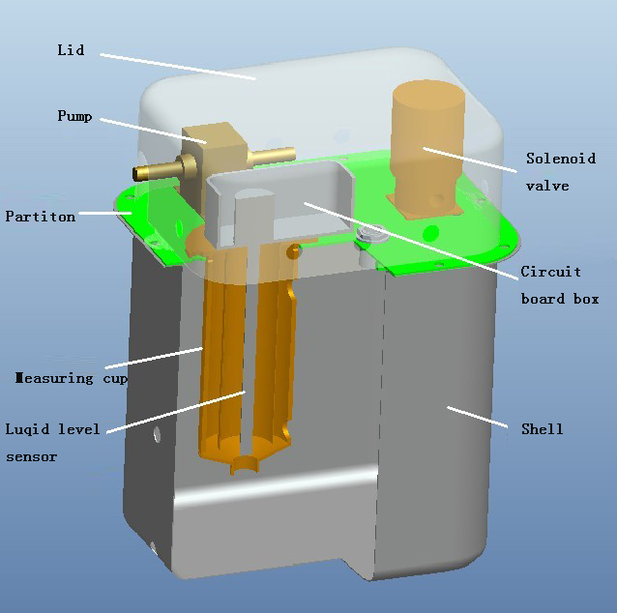
Vehicle Fuel Consumption Monitoring System
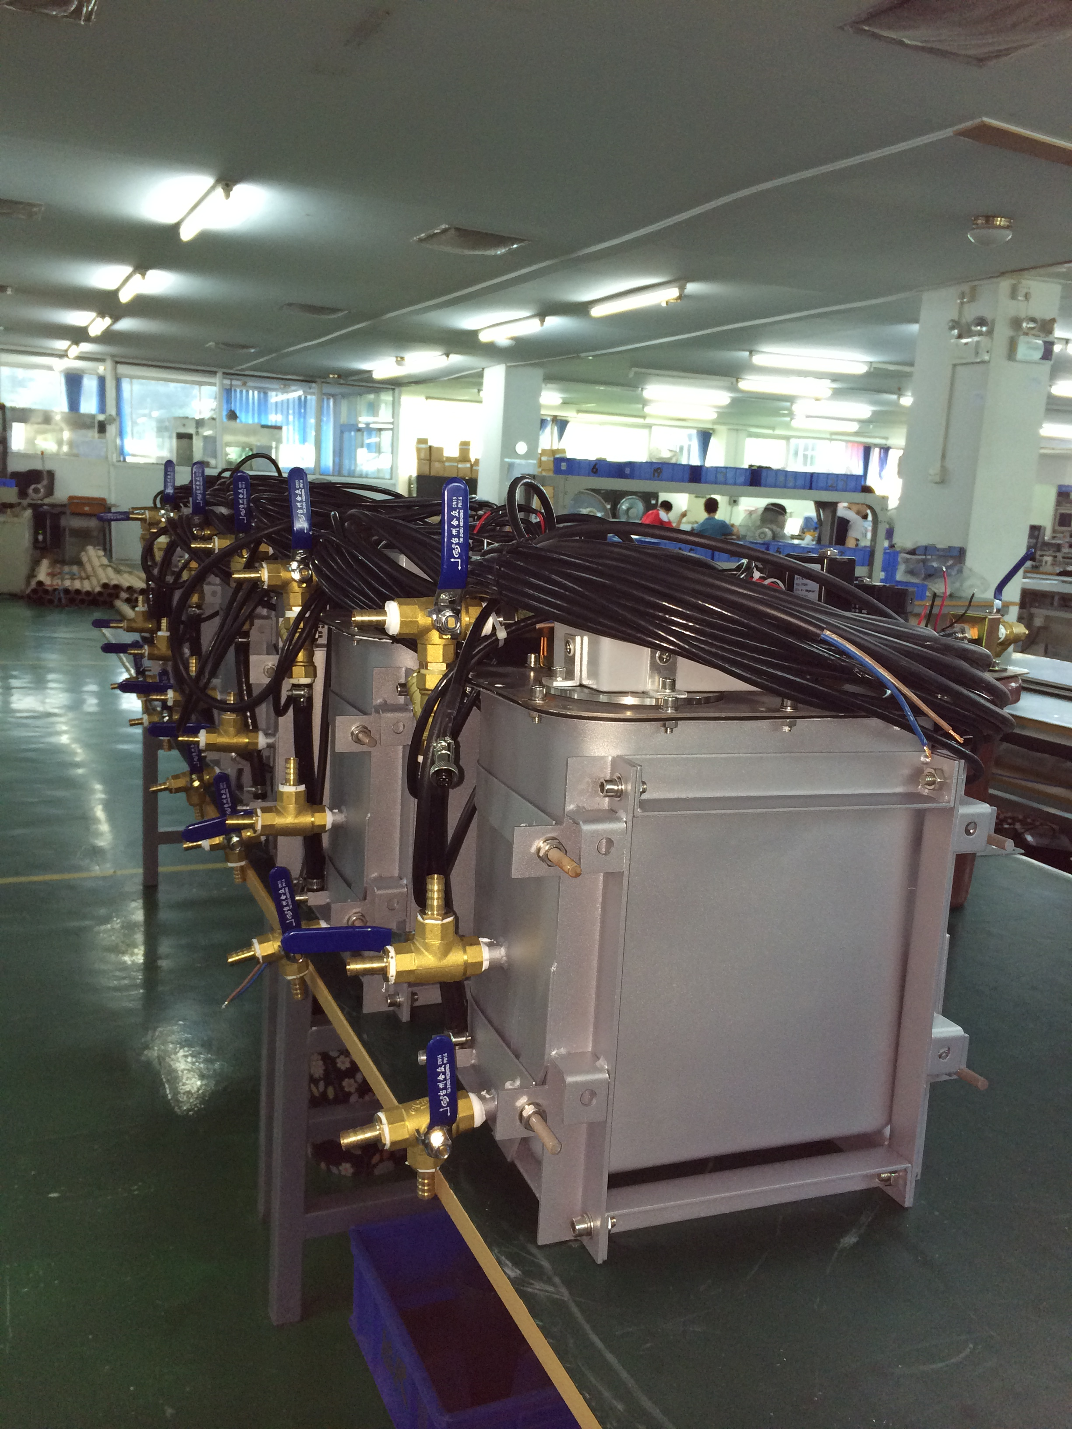

Description：
Fuel Consumption System is used to measure diesel engine fuel consumption.
- Fuel management: Accurately measuring the engine's fuel consumption, including the measurement of engine oil quantity
2. Combine with GPS to realize vehicle management:
◆ Real-time monitoring of the condition of vehicle oil, speed, location, route, etc
◆ Effective management for diesel stolen, achieves the goal of people and cars management.

Specifications:
Parameter | Value
Operating Voltage | DC24V±2V
Accuracy | ≤±1%
Output Signal | Customized (such as total amount of consumption)

Working Principle:

The system is mainly composed of measuring cup, liquid level sensor, small tank and intelligent digital processing units. Liquid level sensor to detect the oil level of measuring cup, when the oil level of measuring cup reach the low limit, oil supplies from inside the vehicle fuel tank. When oil level reach the up limit, the pump stop, the valve opens at the bottom of the cup, the oil in the cup flows into the small tank. The small tank supplies to the engine through tubing oil. During oil compensating, the valve closes at the bottom of the cup, the oil in the cup will not into the small tank. By this way the liquid level sensor detect and measure the oil level of the cup to obtain the engine's fuel consumption.
Security
1. Inlet, outlet and oil return with switching valve, in case fuel consumption system malfunction it can switch back to the original oil pipeline, to ensure that the car keeps moving.
2. Fault code hinting function, after the fuel consumption system communicates with GPS, the operator can understand the cause of the problem via the code display by GPS
3. Fault alarm function, when there is abnormal for fuel consumption system, indicator light and buzzer immediately run, remind the operating personnel for troubleshooting.

Xinhui KangYu Control Systems Engineering, Inc.
Guifeng Hightech Village, Ximen Rd., Xinhui District, Jiangmen City, Guangdong 529100, P.R. China
Tel: 86-750-6318857 Fax: 86-750-6318900 E-mail: sale@chinakangyu.com Website: www.chinakangyu.com

